# Week1

# Lesson 1: Problems Databases Solve

## 1.1 Problems with Having a Lot of Data Used by a Lot of People

* Easy retrieval
* Easy updating
* Accessibility for multiple people at the same time
* Data consistency
* Space efficiency
* Speed
* Security

## 1.2 How Relational Databases Help Solve Those Problems

Relational databases organizes data sets into smaller tables that each have their own unified theme

Set theory requirements:

1. Single tables should represent the smallest logical part of a data set.

2. Each column in a table must represent a unique category of information.

3. Each row in a table must represent unique instance of that information as well.

4. Order of columns or row in a table can't matter.

# Lesson 2: Database Design Tools

## 2.1 Database Design Tools That Will Help You Learn SQL Faster

## 2.2 How Entity-Relationship Diagrams Work

Entities:

Categories of similar but unique measurements

Weak entities:

An entity that depends on the existence of another entity. In more technical terms it can be defined as an entity that cannot be identified by its own attributes. It uses a foreign key combined with its attributed to form the primary key

Attributes:

Unique measurements within a category

Multivalued Attribute:

If an attribute can have more than one value it is called a multi valued attribute

Derived Attribute:

An attribute based on another attribute

Unique attribute:

Unique key

Partial attribute:

Won’t identify an entity on its own

Connect to the unique key of the entity it is connected to with a double diamond

Entity instance: a row

Relationships:

Relationships between entities

Composite attributes: ()

Can be completely reconstructed using other entities

<http://creately.com/blog/diagrams/er-diagrams-tutorial/>

Cardinality constraints:

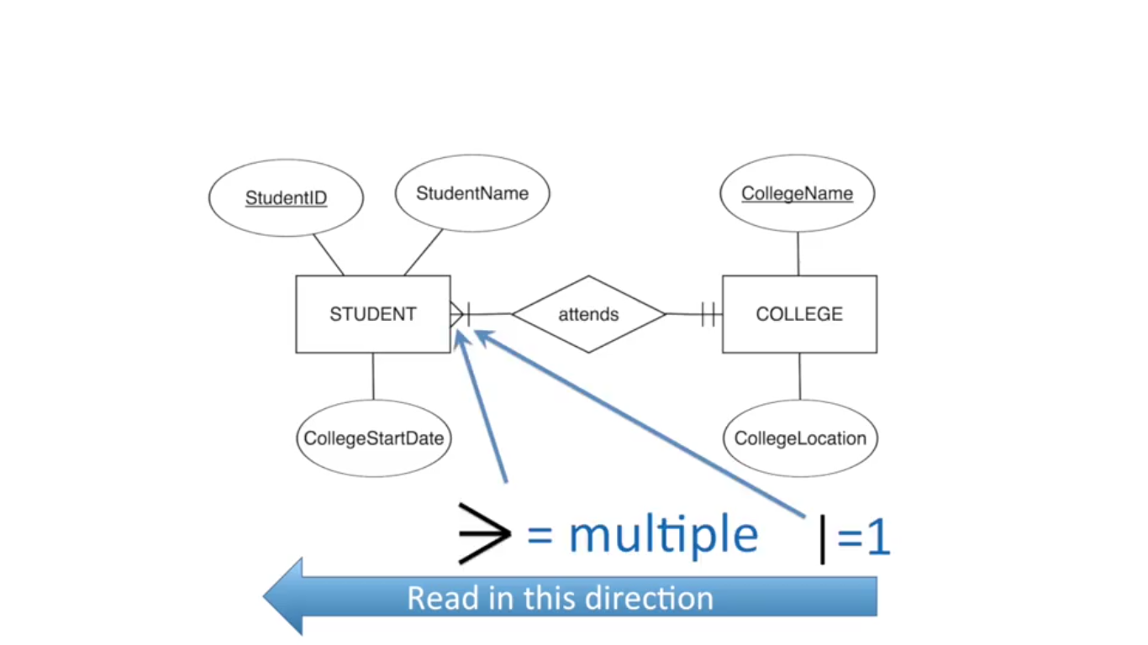

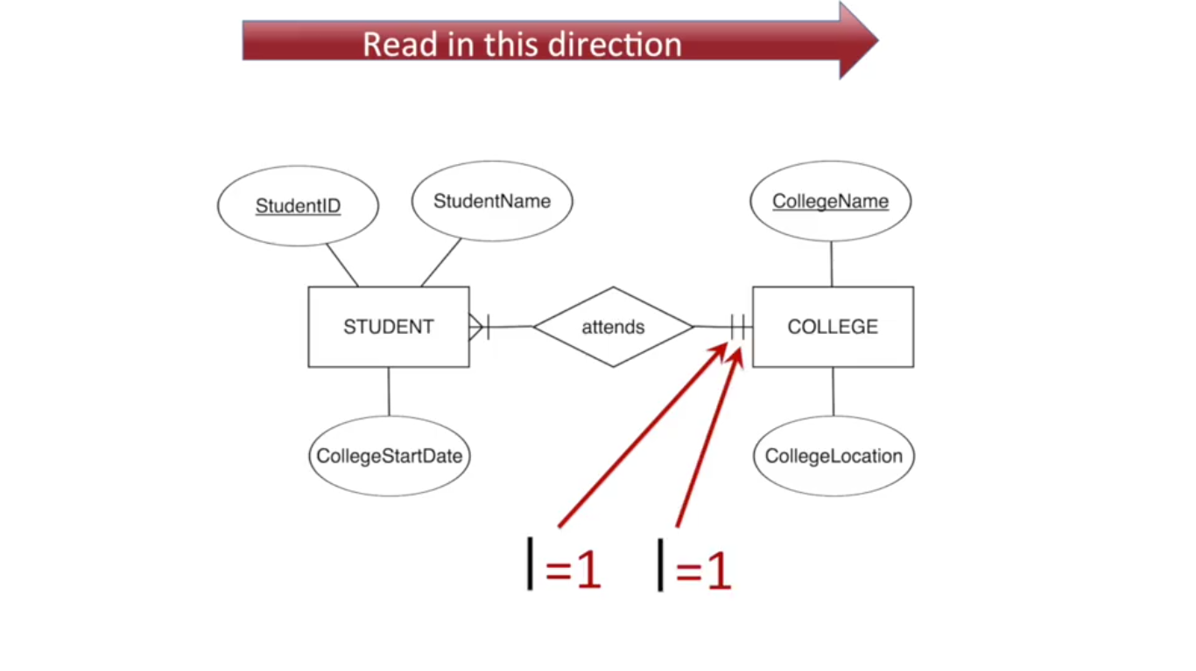

1. Each COLLEGE must be attended by at least one STUDENT but can be attended by many students.

2. Each students attends a minimum of 1 but no more than 1 COLLEGE.

3. M: infinite

4. O: optional

5. Numbers take precedence over symbols (min, max)

## 2.3 Database Structures Illustrated by Entity-Relationship Diagrams

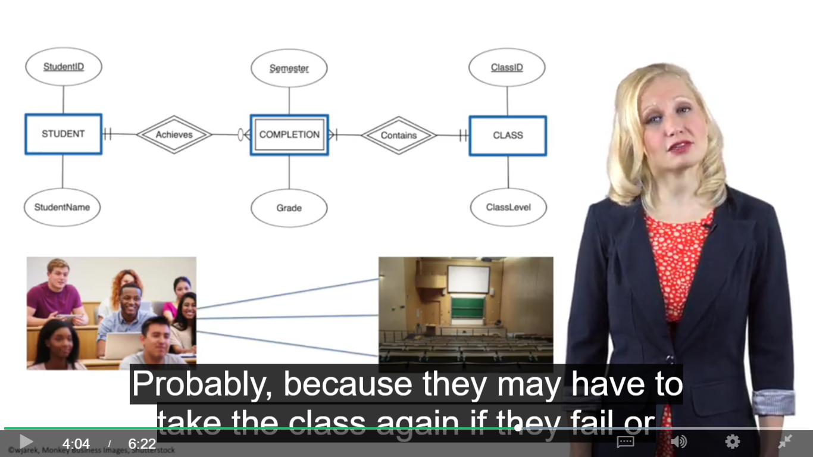

Completion is a weak entity, it has to be combined with student and class to form a unique identifier, a student can take the same classes 0 times or many times in different semesters.

## 2.4 Relational Schemas

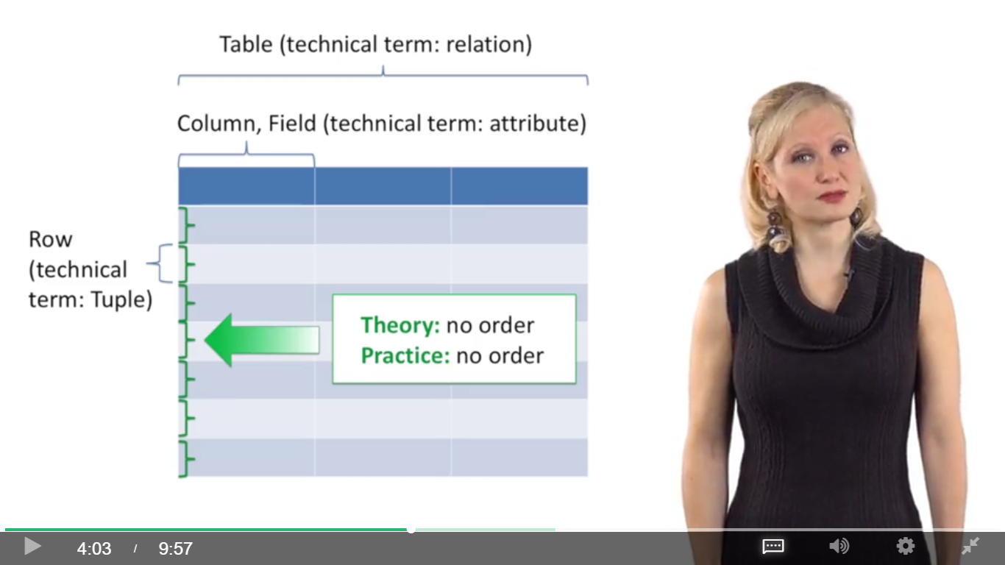

Primary key: column whose value is unique for every row in a table

Foreign key: column that refers to the primary key of another table ( -> point to the primary key)

One to many:

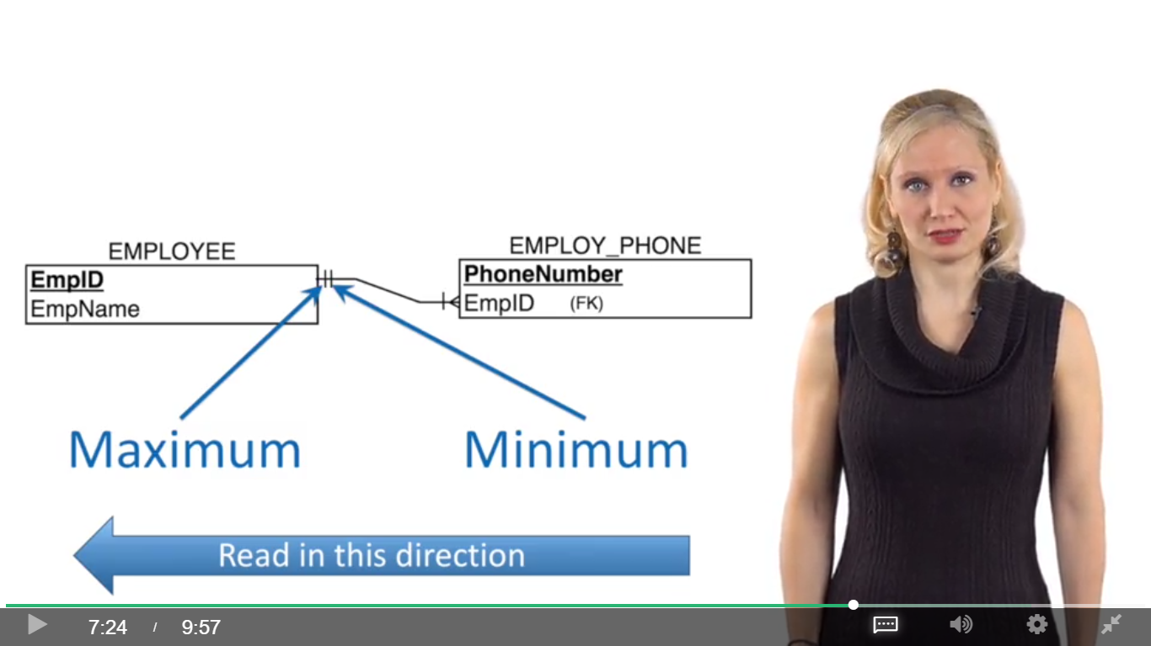

Many to Many:

Enrollsin is a mapping table, has only one composite primary key made up of two foreign keys

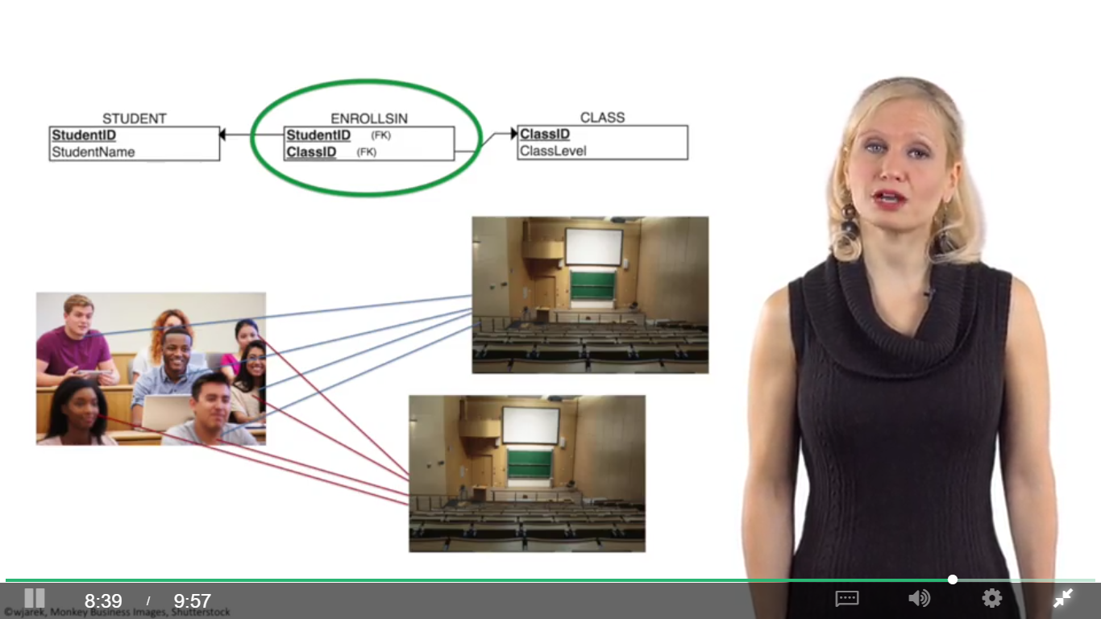

# Lesson 3: Building Your Own Entity-Relationship Diagrams

<https://erdplus.com>

The arrow goes from the table that has a foreign key to the table where the key comes from (so the arrow points to the primary key).

Whenever you have a 1:Many relationship, the relation mapped from the entity on the Many side of the relationship should get a foreign key that corresponds to the primary key of the relation on the 1 side of the relationship. This is because you would have to have duplicate values of the unique identifier of the entity on the 1 side in the table that represents the entity on the Many side.

Whenever you have a Many:Many relationship, on the other hand, recall that you will need a separate linking table that will have two foreign keys corresponding to the primary keys of the tables that represent the entities in the Many:Many relationship.

# Week2

# Lesson 1: Meet Your Business Data Sets

# Lesson 2: Using the Jupyter Interface for MySQL Queries

## 2.1 Introduction to Query Syntax

Query: SQL code that describes the data you desire and the format in which you want it

Front end interface: where users enter queries

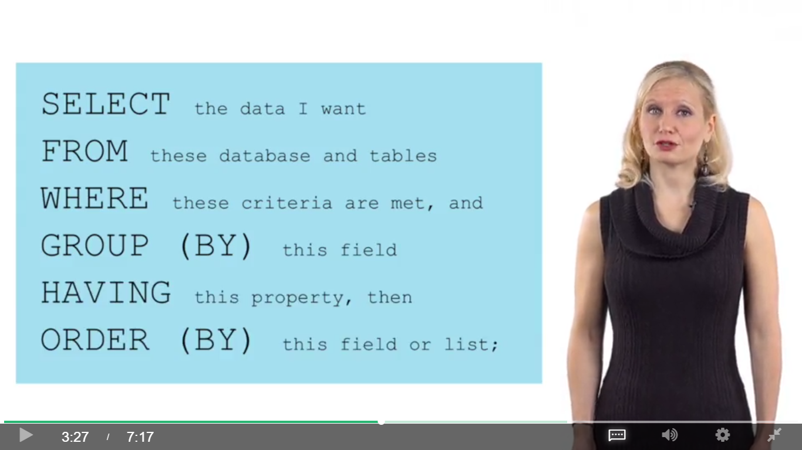

Keep the key words Capitalized

No data = Null, 0 != Null

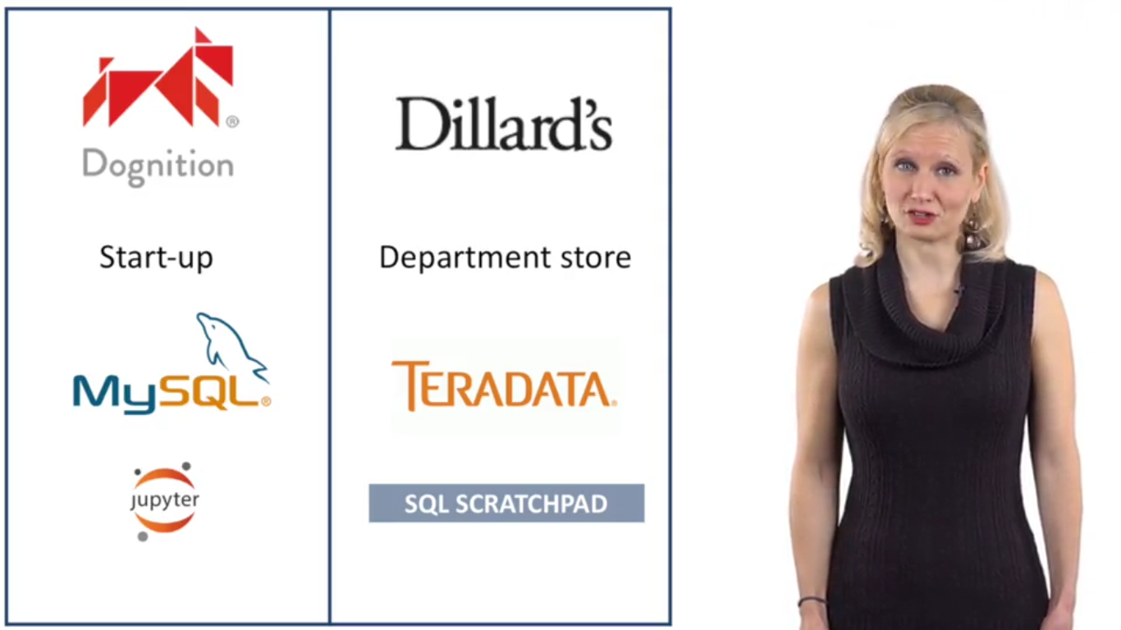

## 2.2 How to Use Jupyter Notebooks

# Lesson 3: SQL Queries for Looking at Your Data

# Lesson 4: Setting Criteria with WHERE

# Lesson 5: Formatting Result Using Aliases, DISTINCT, and ORDER BY

# Lesson 6: Using the Viewpoint Interface for Teradata Queries

## 6.1 How to Use Teradata Viewpoint and SQL Scratchpad

Pin and unpin

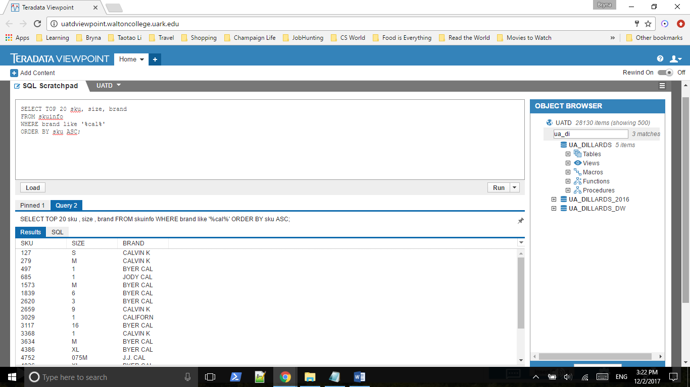

## 6.2 Teradata Practice Exercises Guide

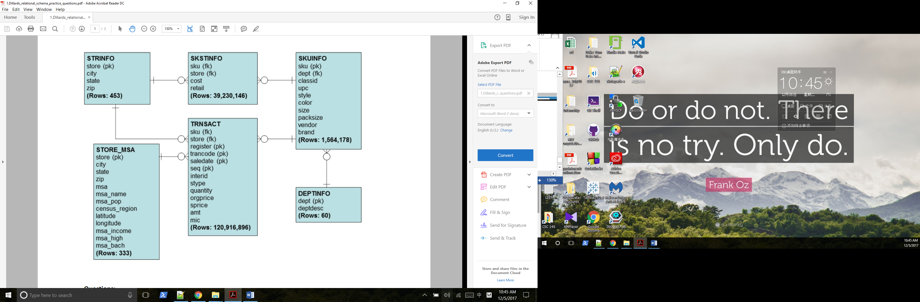

A **stock keeping unit** (SKU) is a product and service identification code for a store or product, often portrayed as a machine-readable bar code that helps track the item for inventory. A **stock keeping unit** (SKU) does not need to be assigned to physical products in inventory.

SKSTINFOR is the middle bridge between store and sku.

### DEPTINFO:

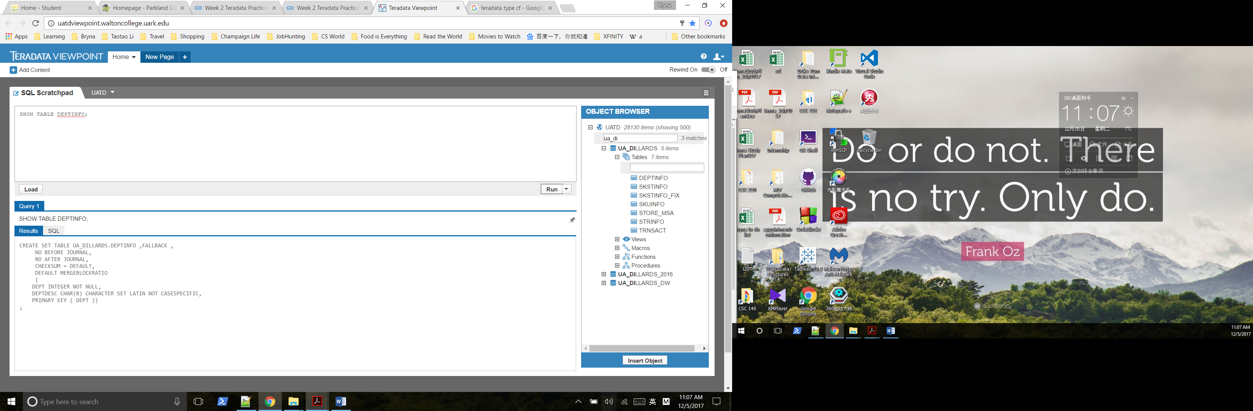

### SKUINFO:

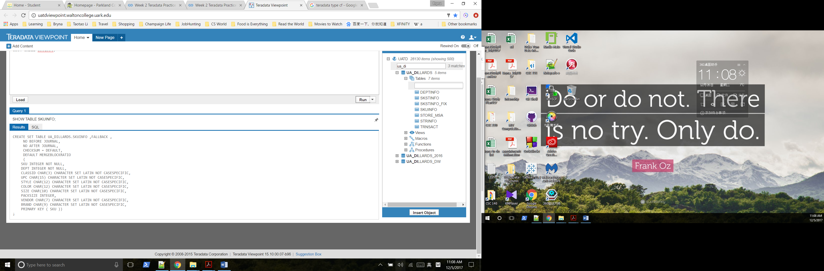

There are a lot of strange values in the “color”, “style”, and “size” fields of the skuinfo

table.

### STRINFO:

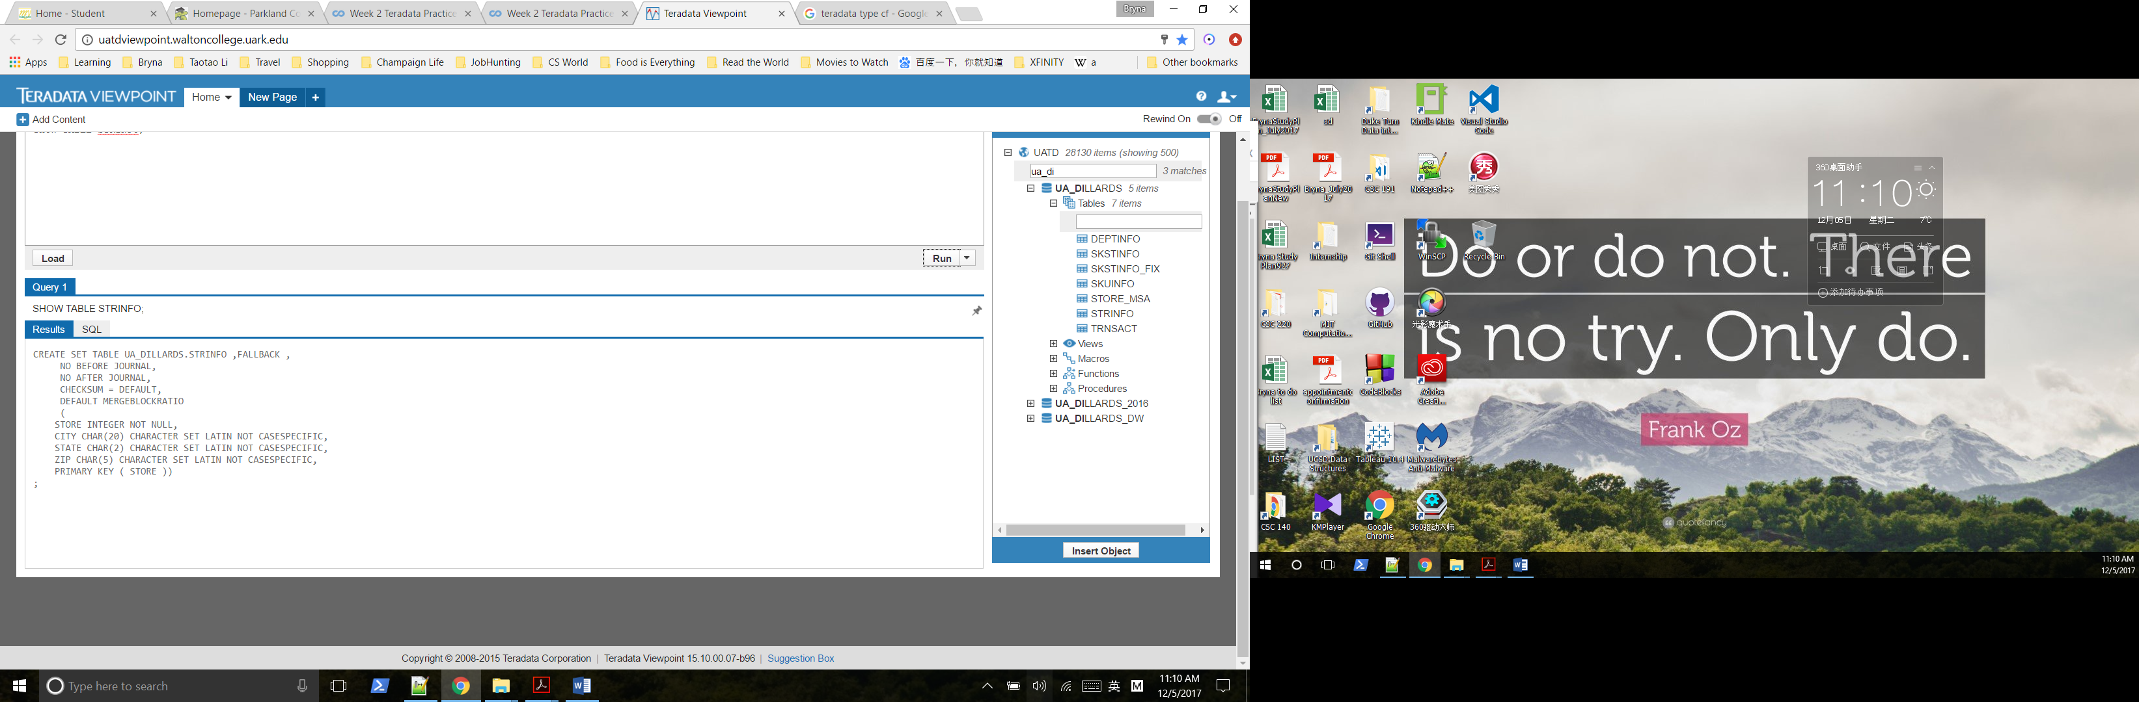

### SKSTINFO:

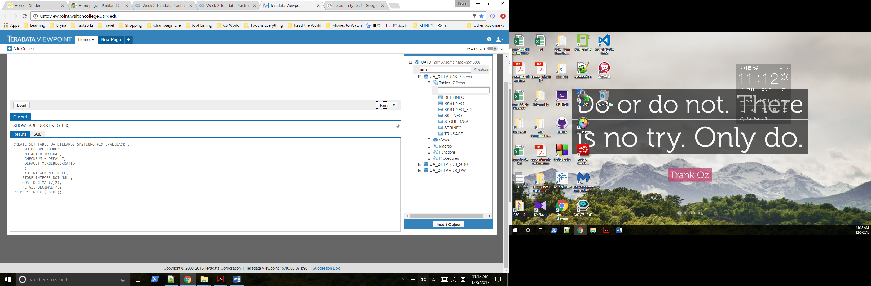

### STORE_MSA:

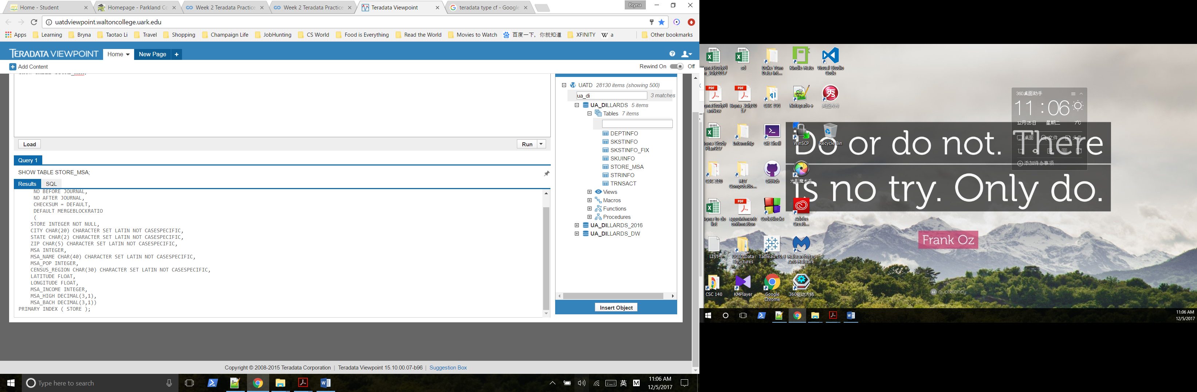

### TRNSACT:

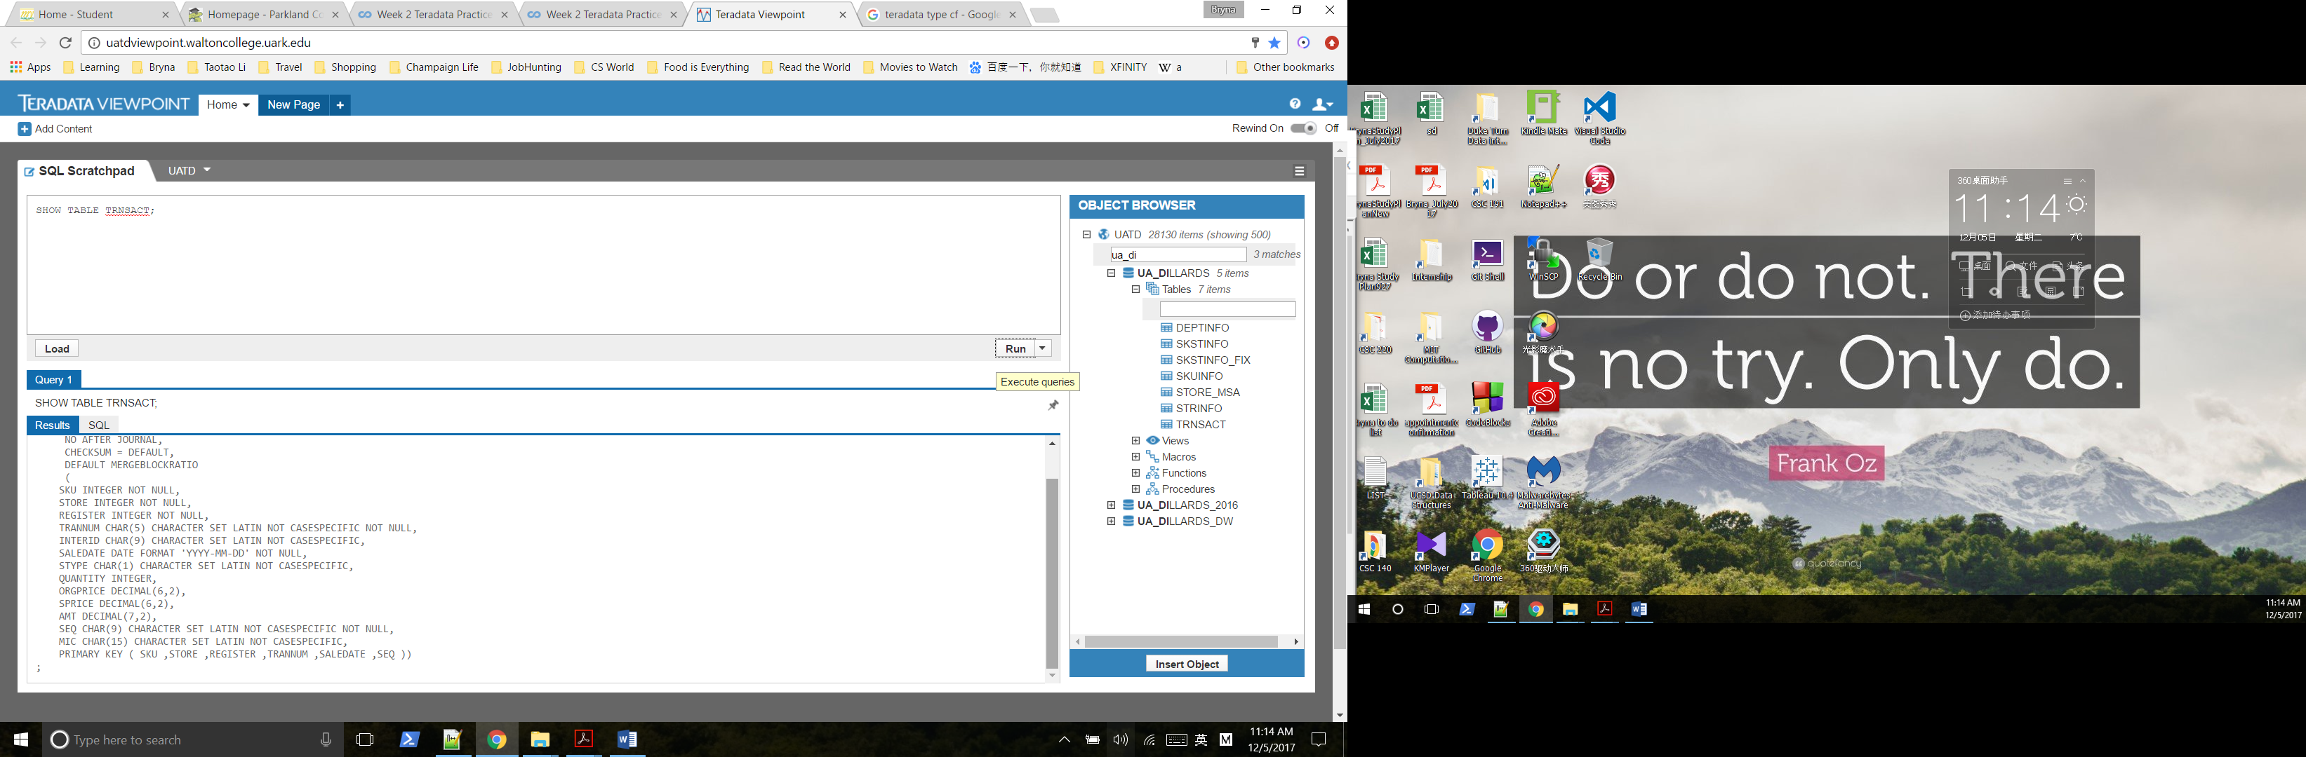

There are two types of transactions: purchases and returns.

AMT = QUANTITY * SPRICE

Errors:

(a) rows in the trsnact table that have “0” in their orgprice column (how could the original

price be 0?),

(b) rows in the skstinfo table where both the cost and retail price are listed as 0.00, and

Managing Big Data with MySQL Dr. Jana Schaich Borg, Duke University

5

(c) rows in the skstinfo table where the cost is greater than the retail price (although

occasionally retailers will sell an item at a loss for strategic reasons, it is very unlikely that a

manufacturer would provide a suggested retail price that is lower than the cost of the item)

# Week 3

## Lesson 1: Summarizing Your Data Using Aggregate Functions

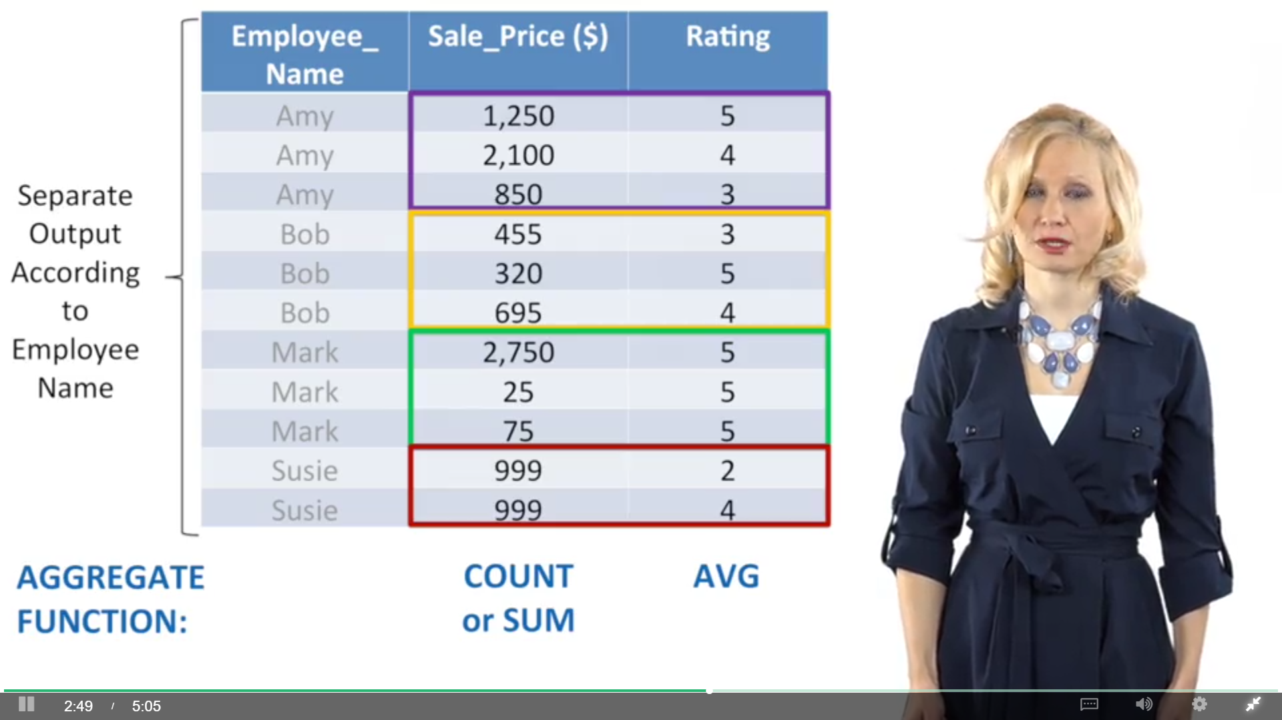

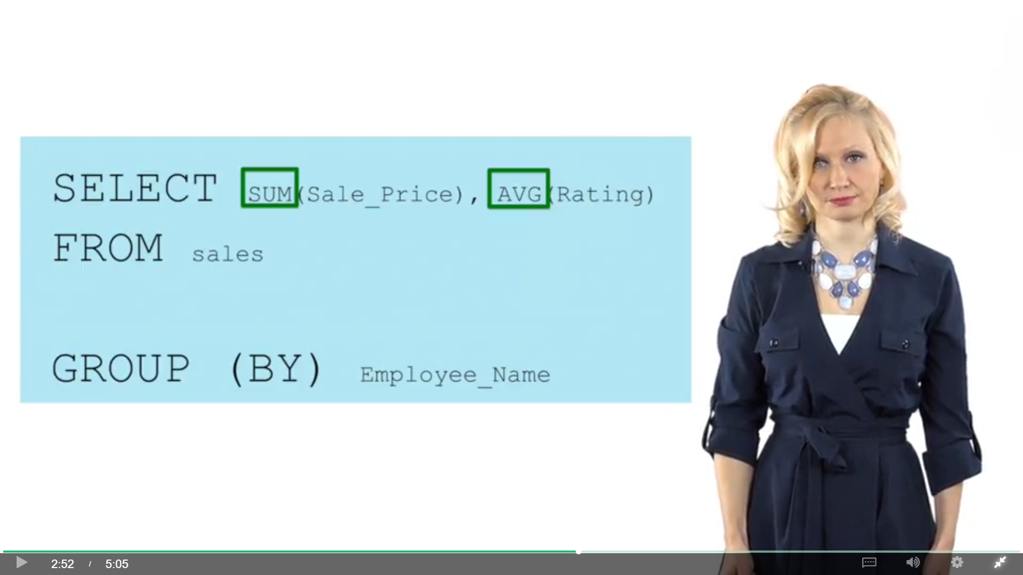

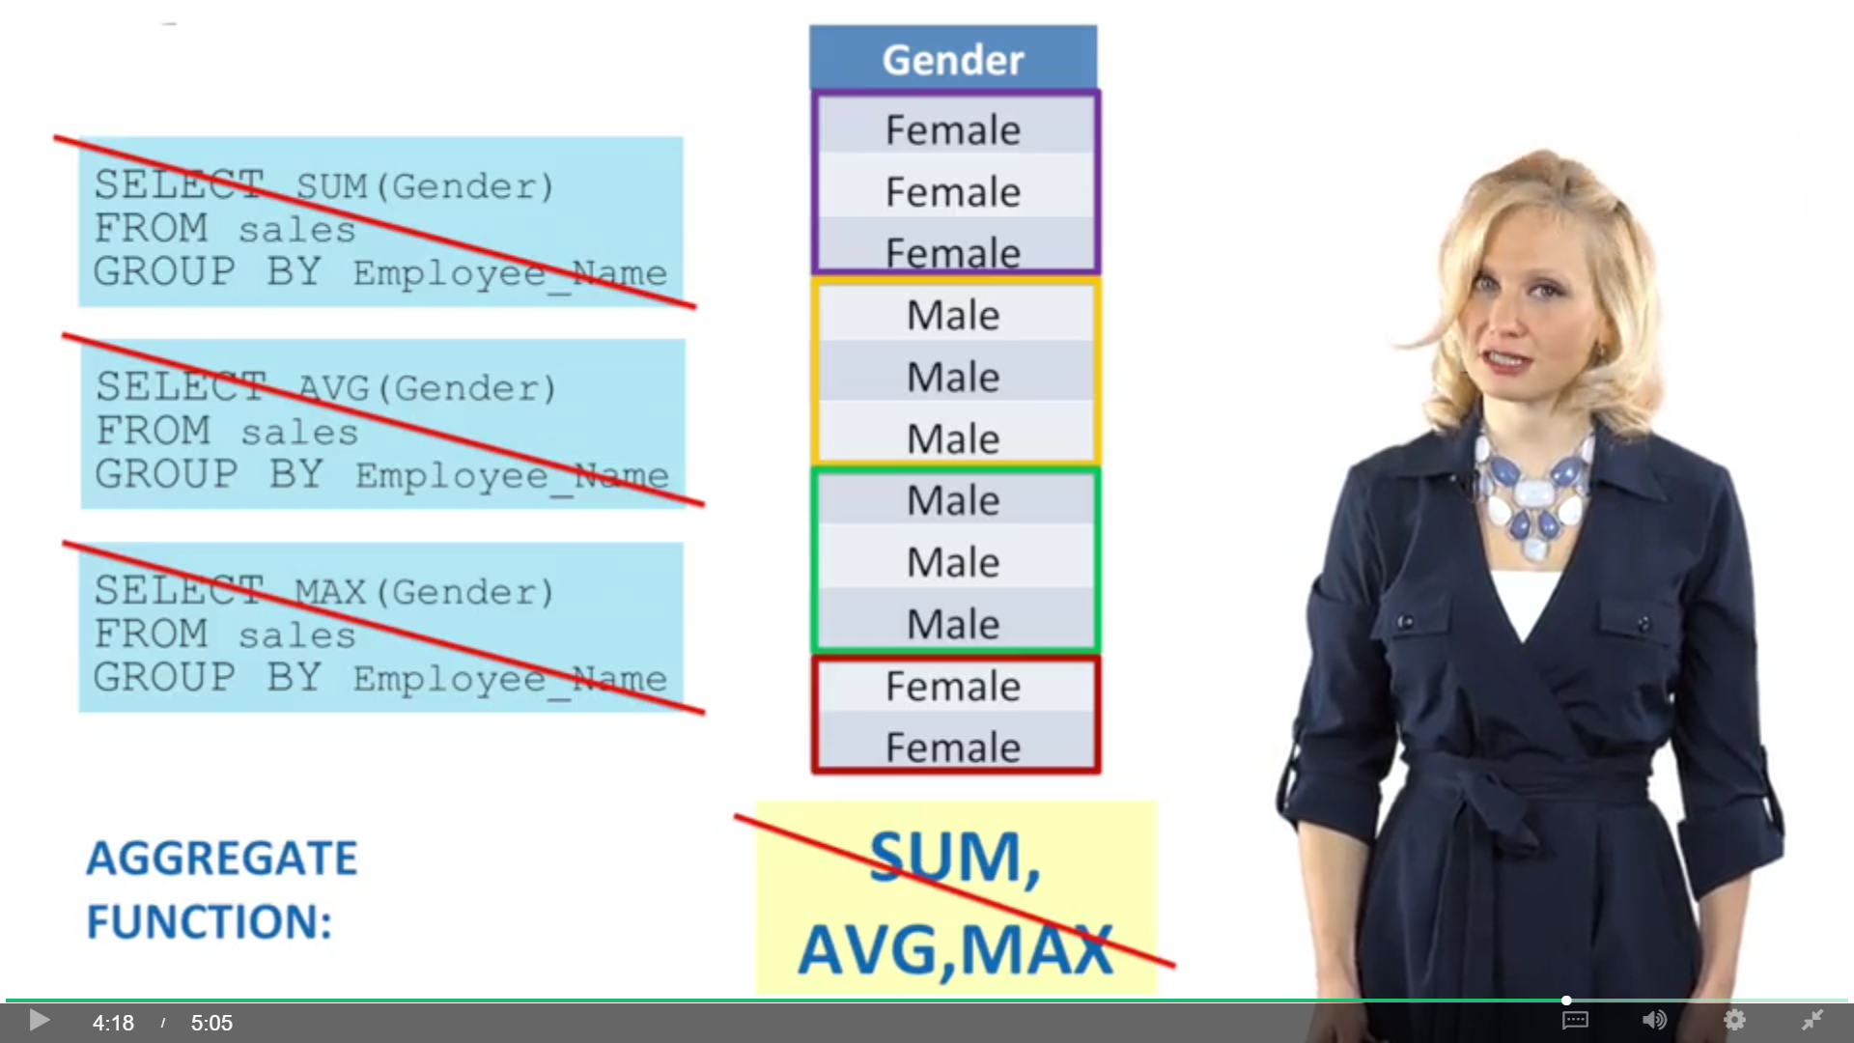

Combining tables is the essence of what makes relational databases useful and once you know how to do it, it unlocks all kinds of analysis possibilities.

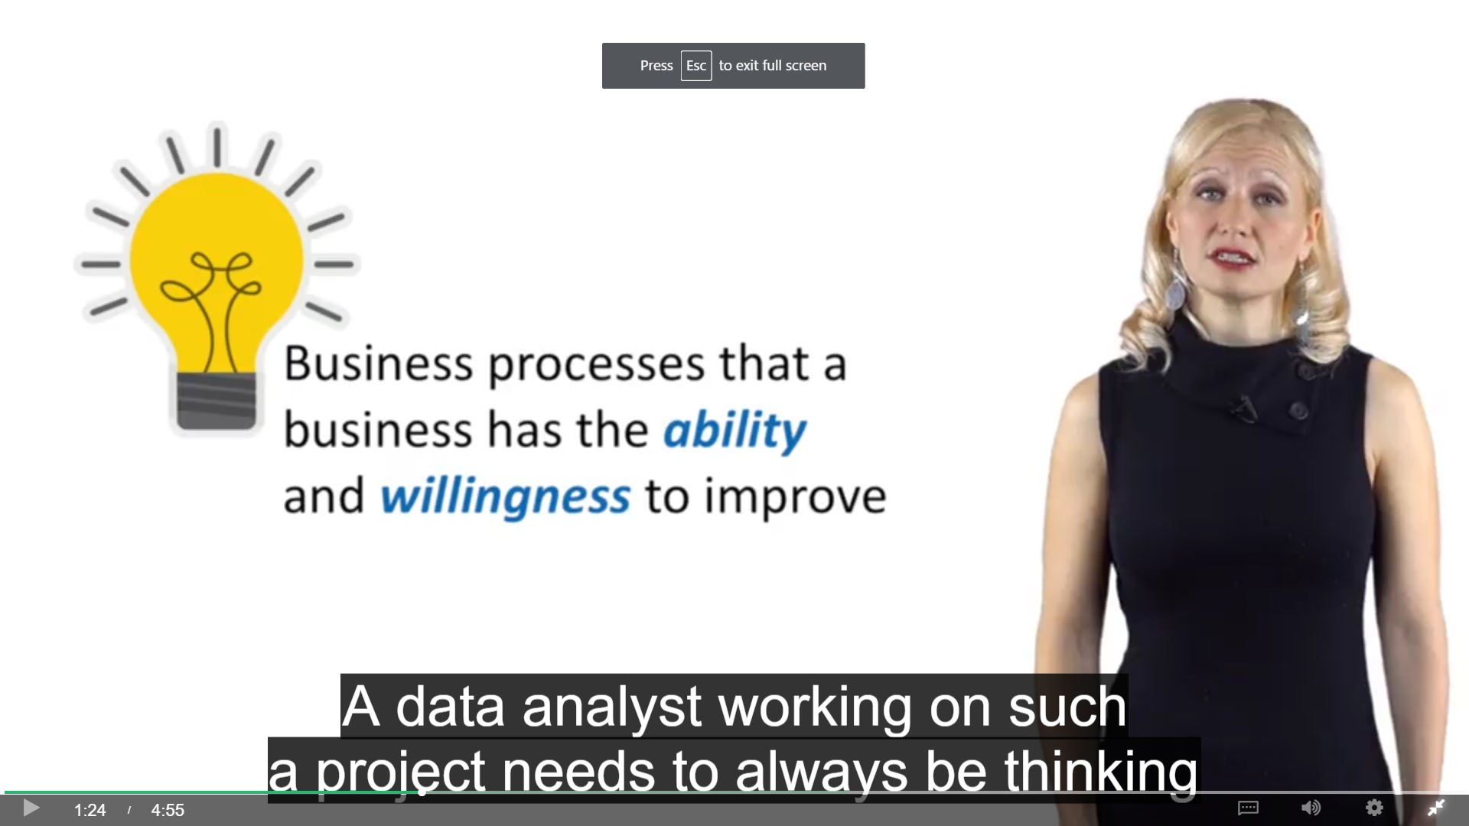

You are creating brand new value for your business that it didn't even know existed.

That's really exciting.

## Lesson 2: Segmenting Your Data Using GROUP BY

 The order the database usually executes the queries:

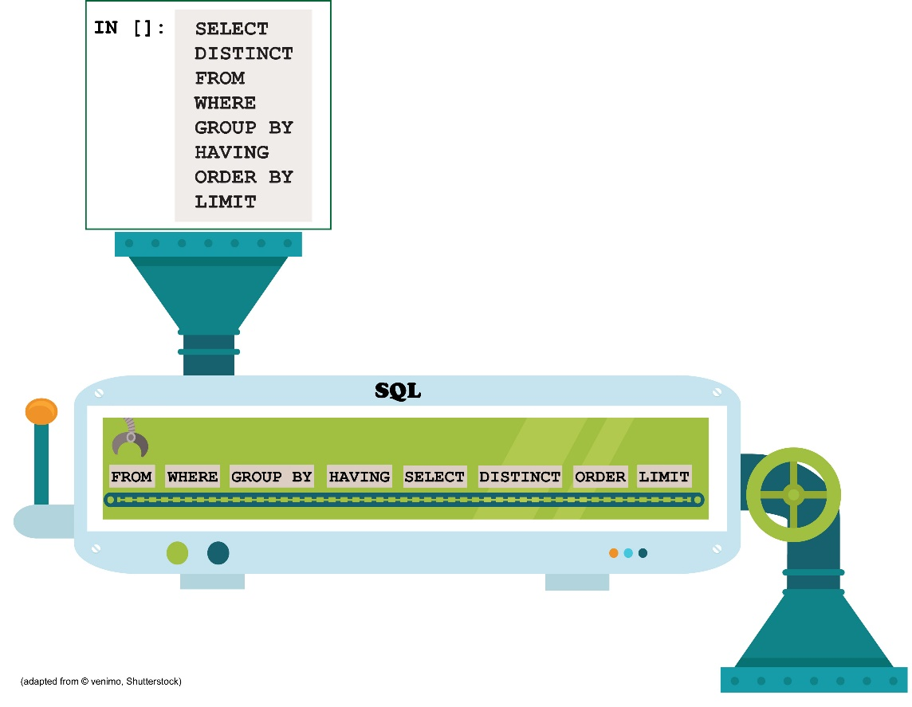

This diagram shows you that data are actually grouped before the SELECT expressions are applied. That means that when a GROUP BY expression is included in an SQL query, there is no way to use a SELECT statement to summarize data that cross multiple groups. The data will have already been separated by the time the SELECT statement is applied. The only way to get the information you want is to write two separate queries. This concept can be difficult to understand when you start using SQL for the first time after exclusively using Excel, but soon you will be come accustomed to it.

By the way, this diagram also shows you why some platforms and some queries in some platforms crash when you try to use aliases or derived fields in WHERE, GROUP BY, or HAVING clauses. If the SELECT statement hasn't been run yet, the alias or derived fields won't be available (as a reminder, some database systems--like MySQL--have found ways to overcome this issue). On the other hand, SELECT is executed before ORDER BY clauses. That means most database systems should be able to use aliases and derived fields in ORDER BY clauses.

## Lesson 3: Joining Tables

### What are Joins?

Cartesian product

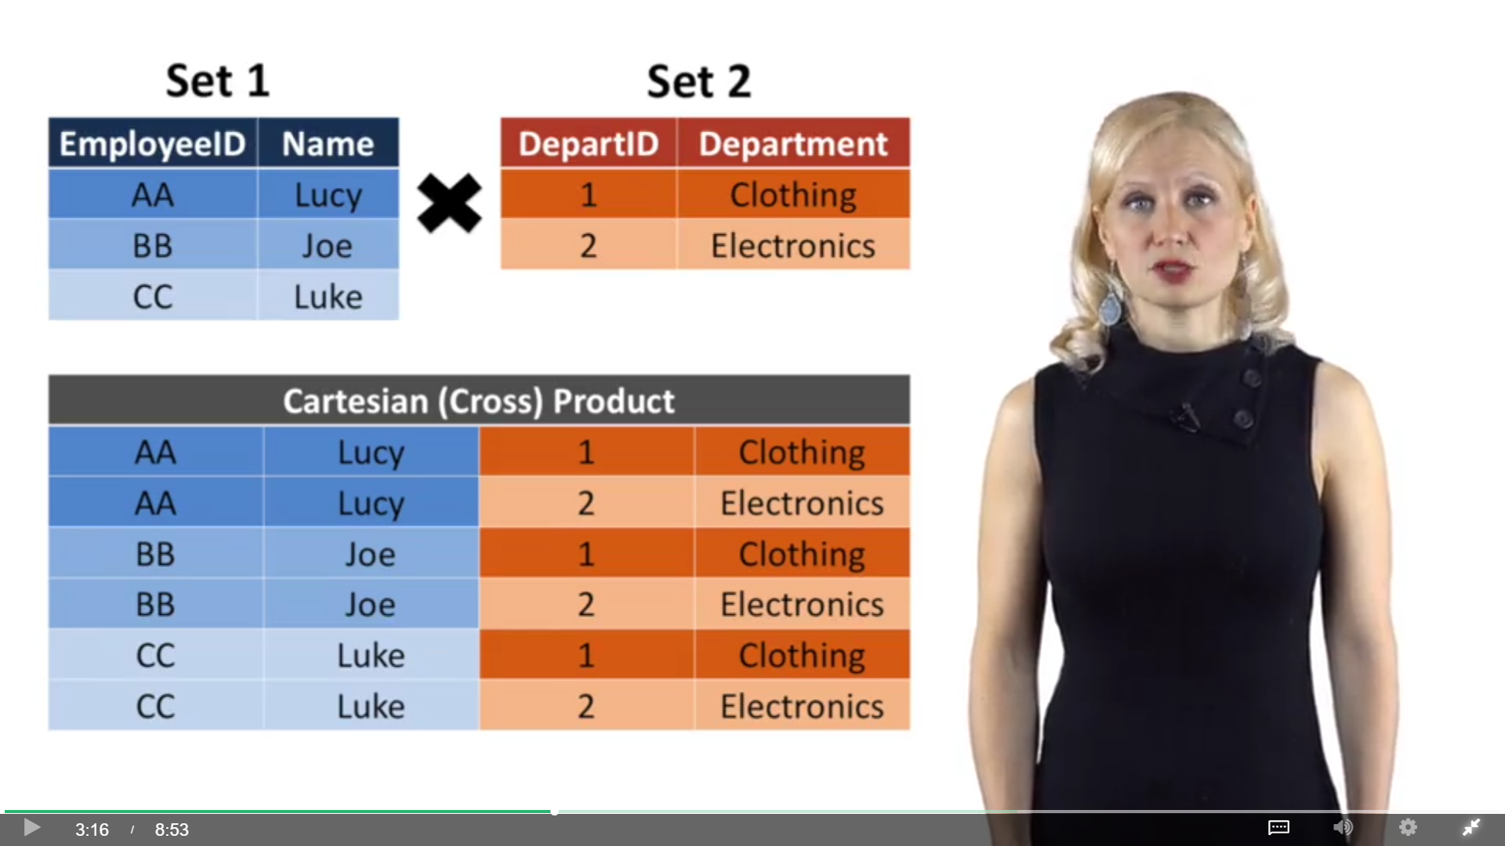

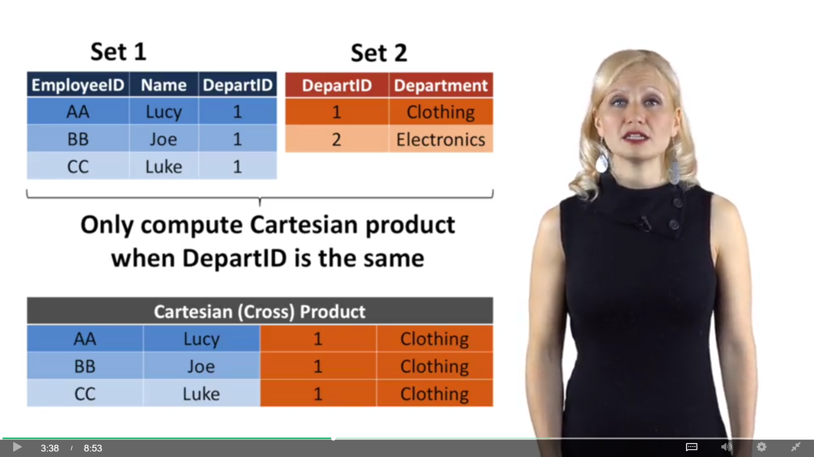

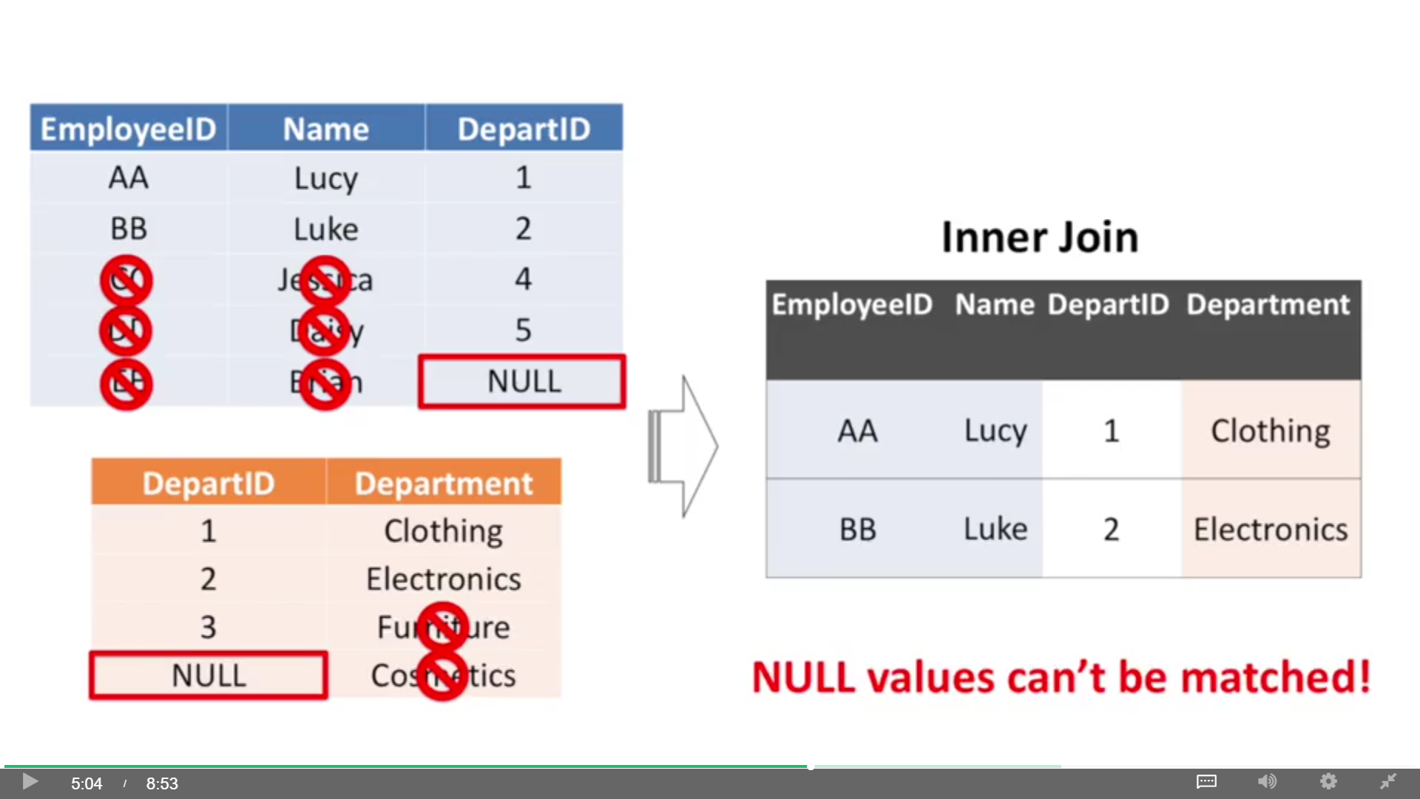

List all employees and their department, regardless of whether their department is in the department table.

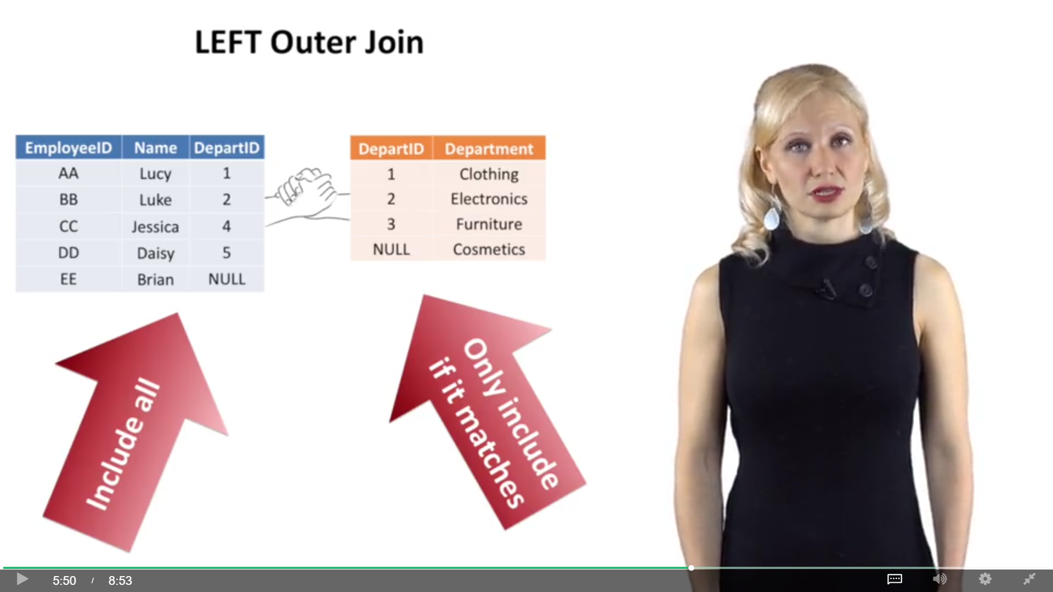

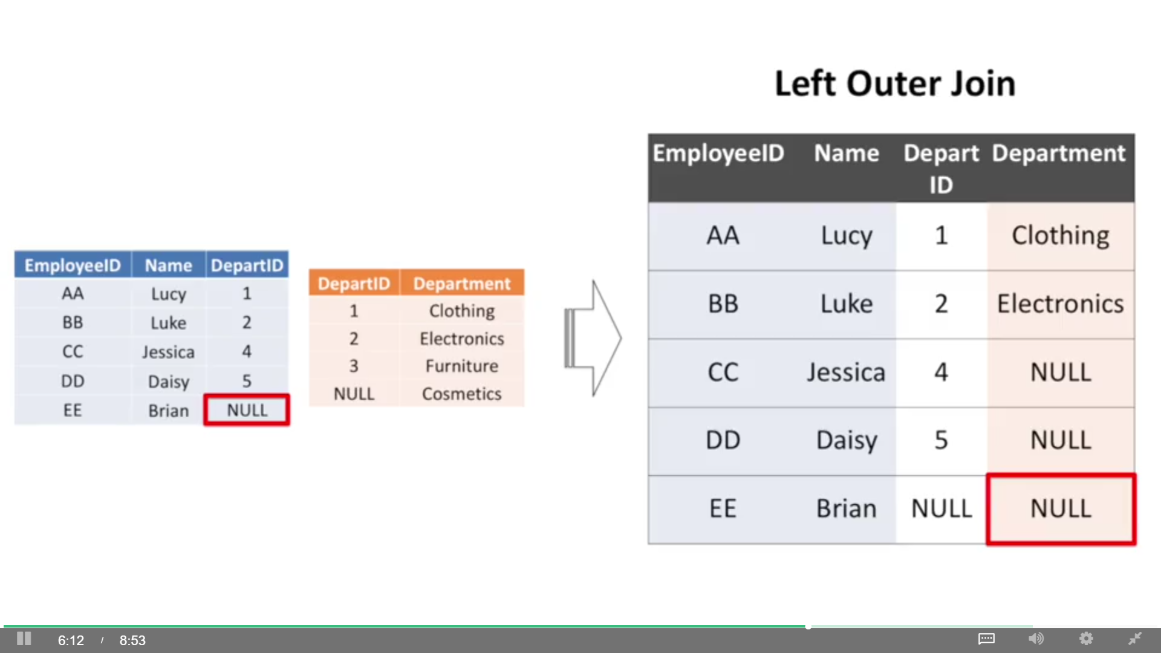

List all departments, regardless of whether an employee is assigned to that department

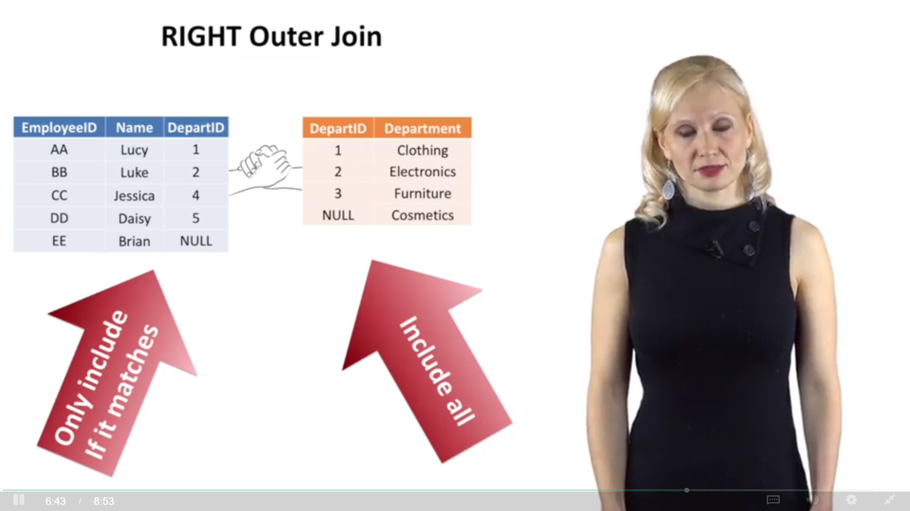

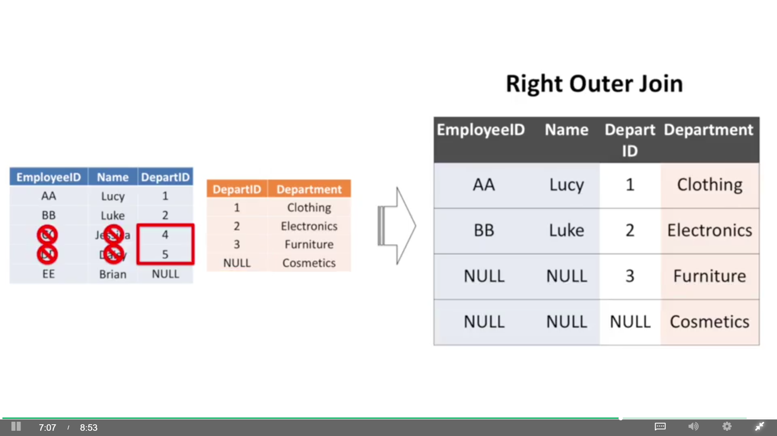

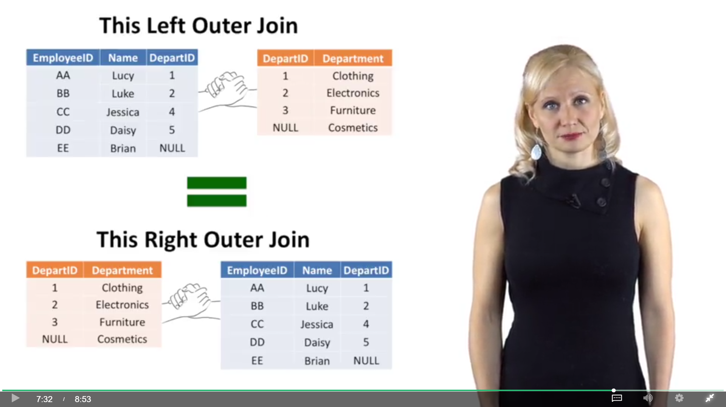

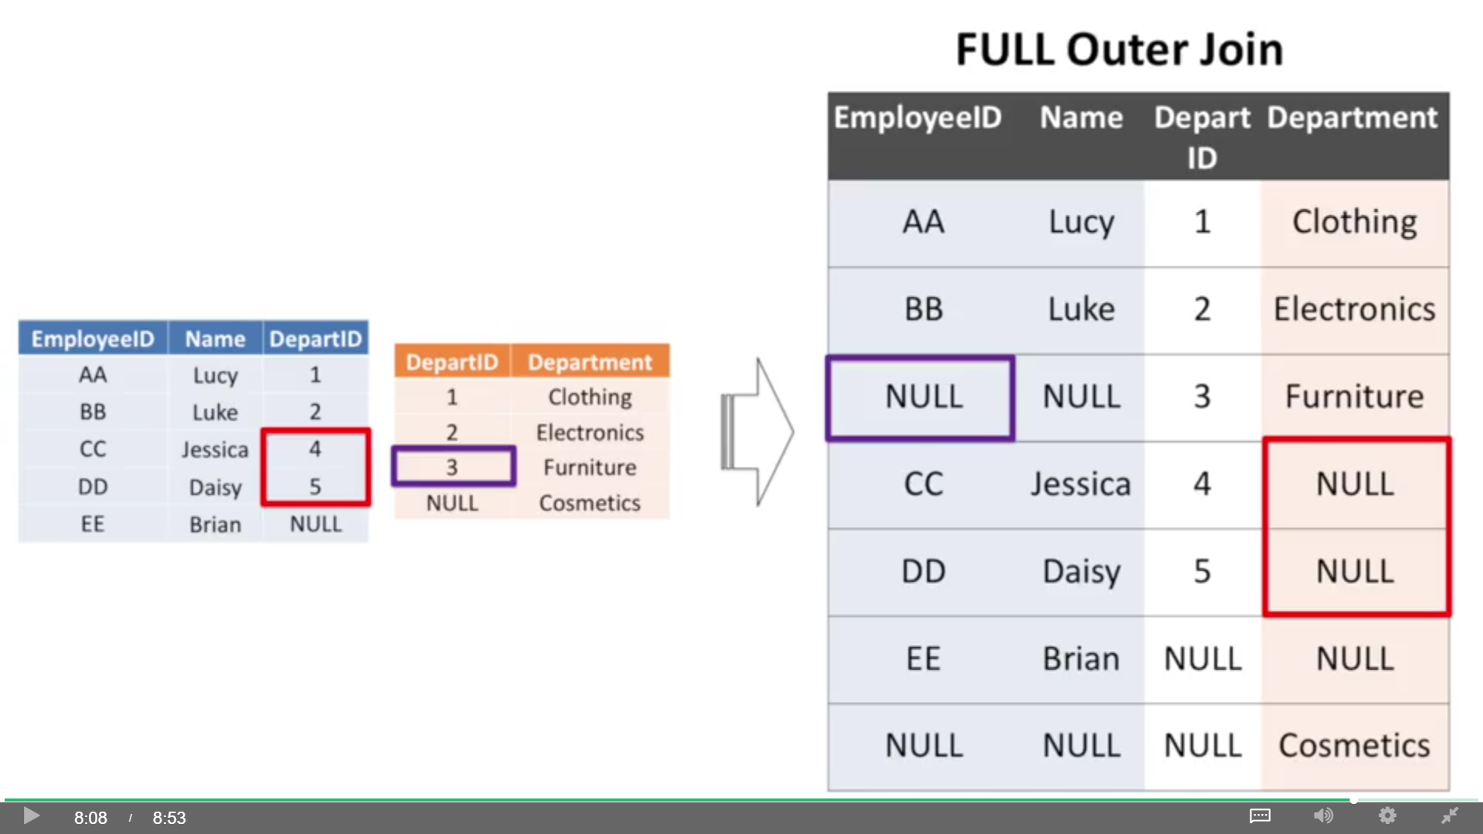

**MySQL doesn’t support FULL OUTER JOIN**

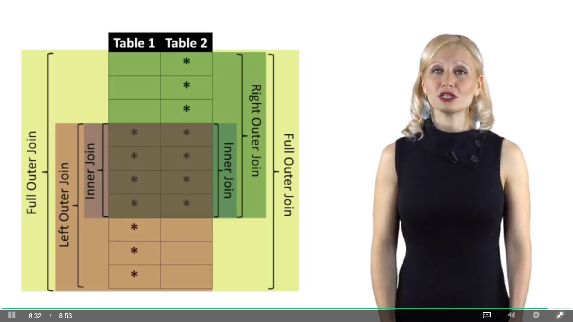

### Joins with Many to Many Relationships and Duplicates

#### An example of inner join has more rows than either of the tables we were joining:

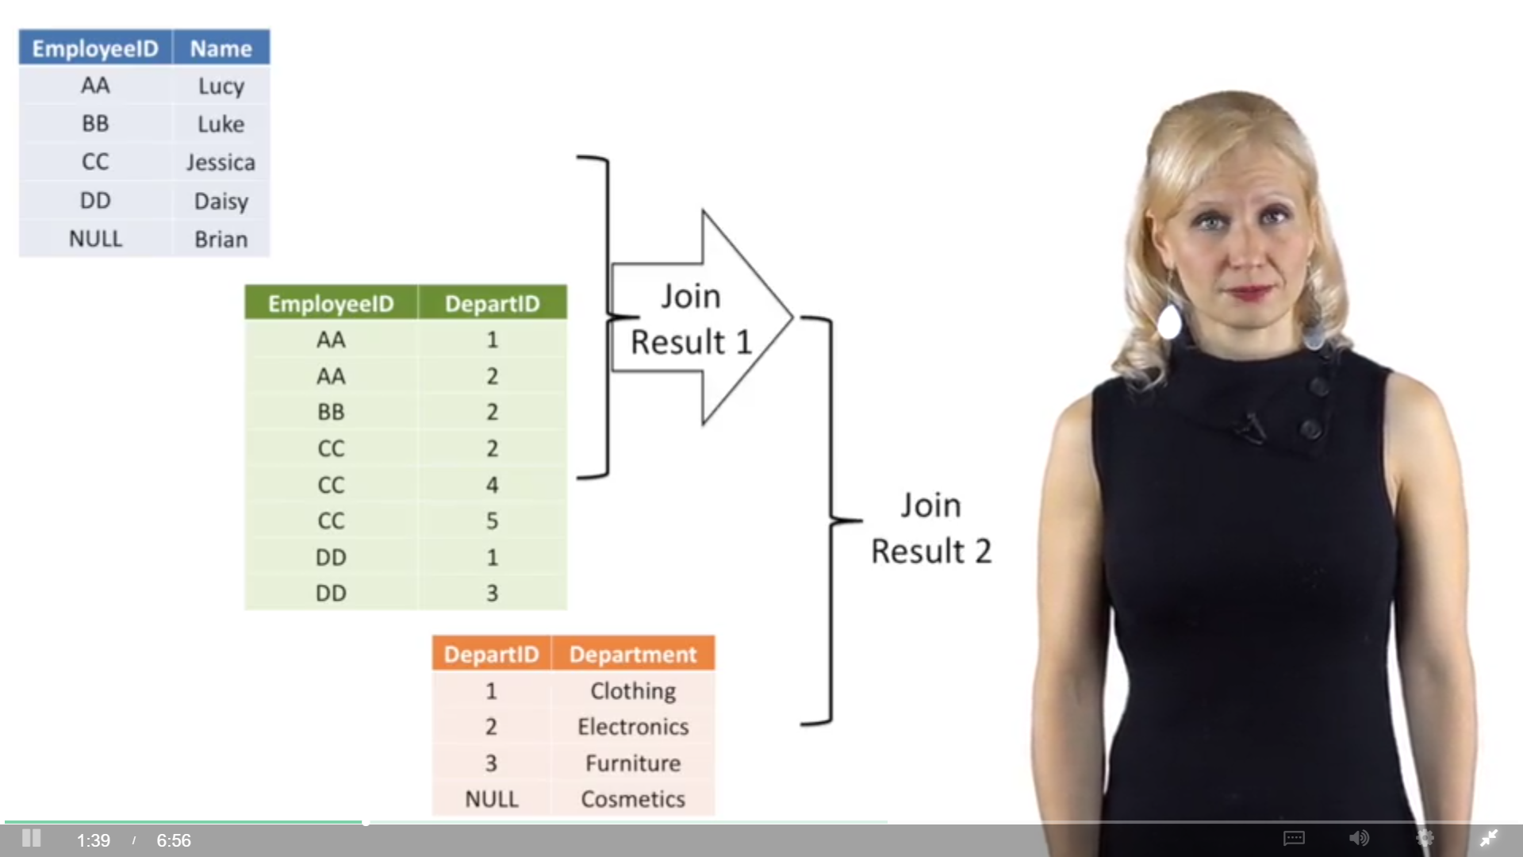

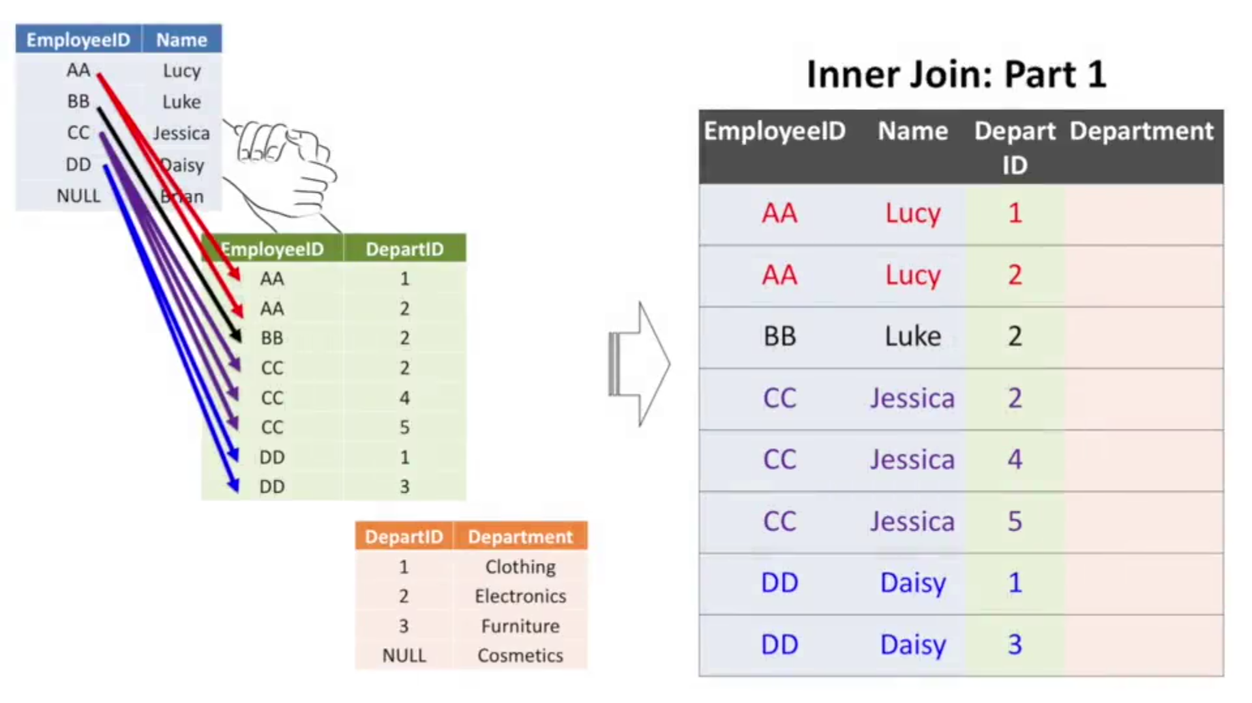

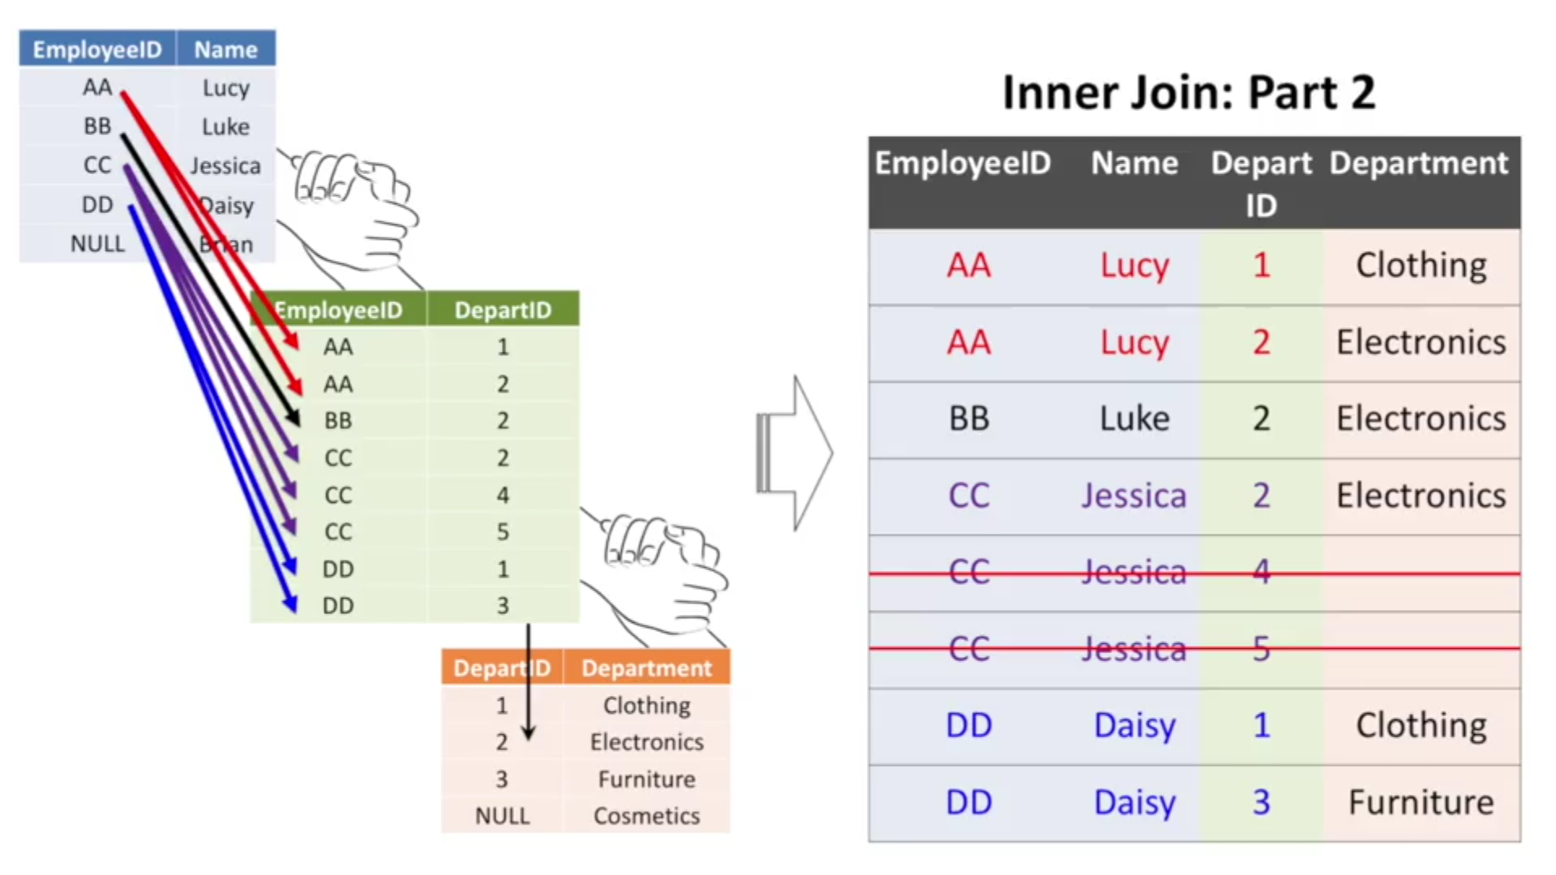

#### When you join multiple tables together using different types of joins:

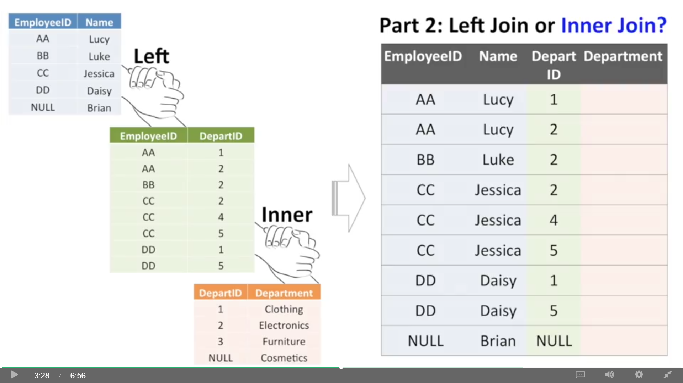

If Inner Join is chosen instead of Left Join:

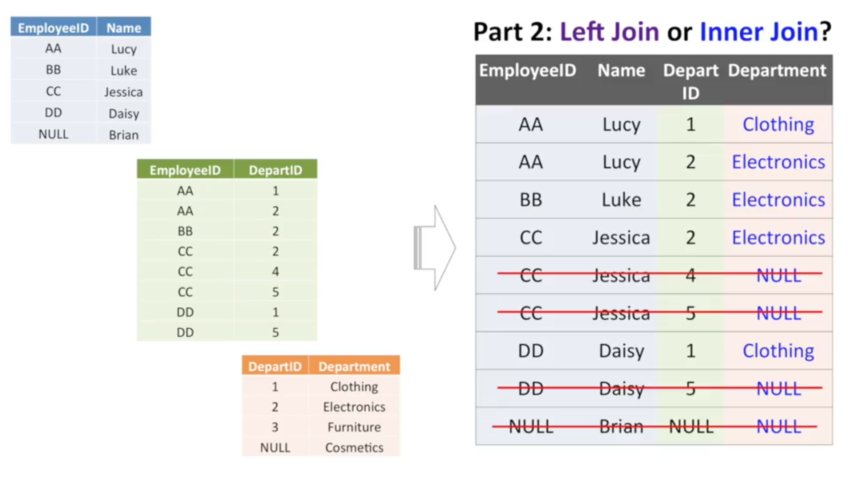

Now, four of our nine rows would be removed, because they don't have department ID'

#### Duplicate rows: your duplicates get multiplied.

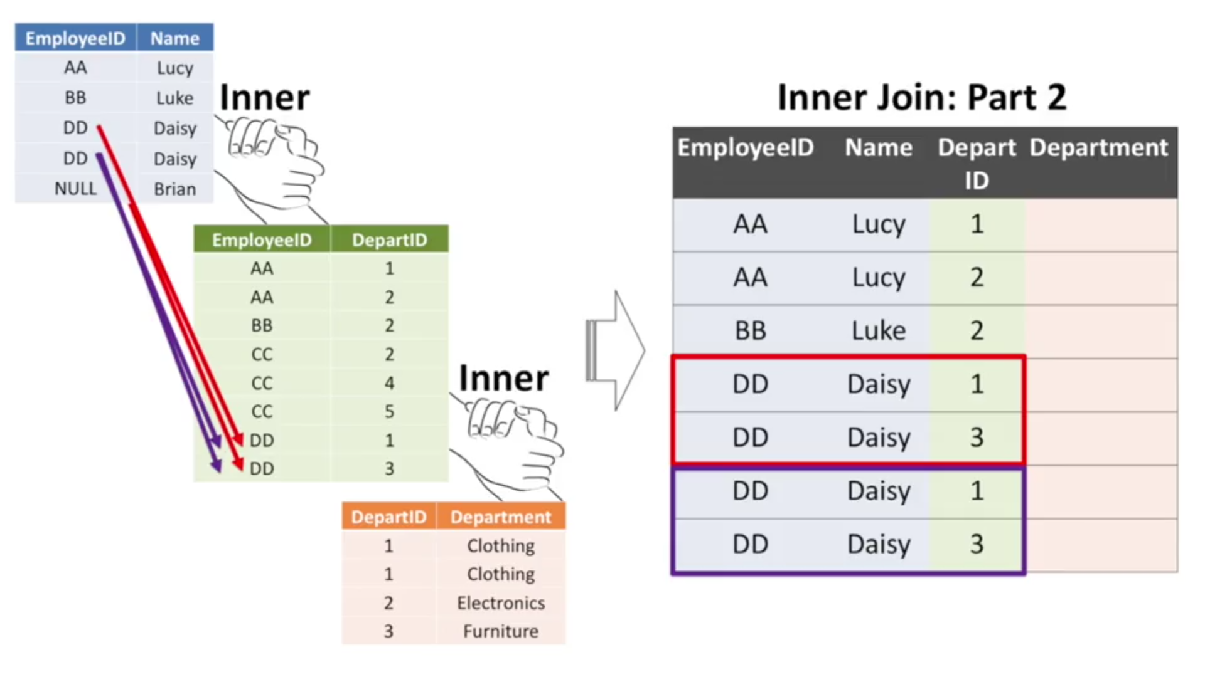

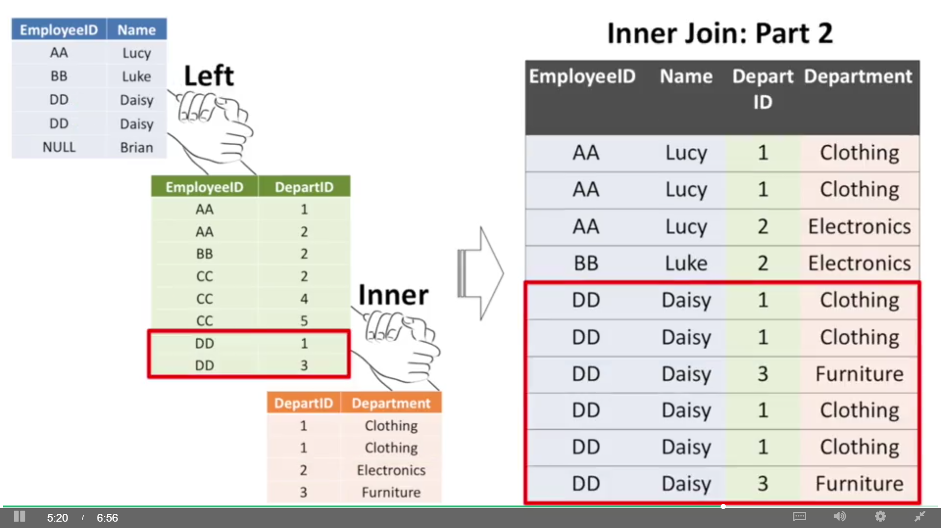

Clean data and try with small samples